**Pizza Sales SQL Queries**

A. KPI Requirements

**1. Total Revenue:**

SELECT SUM(total_price) AS Total_Revenue FROM pizza_sales;

*Output:*

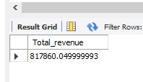

**2. Average order value**

SELECT SUM(total_price) / COUNT(DISTINCT order_id) AS Average_order_value FROM pizza_sales;

*Output:*

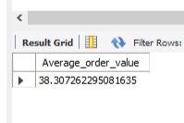

**3. Total Pizza Sold**

SELECT SUM(quantity) as Total_pizza_sold from pizza_sales;

*Output:*

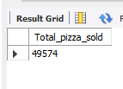

**4. Total Orders**

SELECT COUNT(DISTINCT order_id) AS Total_orders FROM pizza_sales;

*Output:*

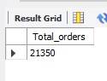

**5. AVG. pizza per order**

SELECT CAST(SUM(quantity) / COUNT(DISTINCT ORDER_ID) AS DECIMAL(10,2))

AS Avg_pizza_per_order FROM pizza_sales;

*Output:*

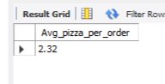

B. Chart Requirements

**1. Daily trend for orders**

SELECT DAYNAME(STR_TO_DATE(ORDER_DATE, '%d-%m-%Y')) AS Order_day , COUNT(DISTINCT order_id) AS Total_orders FROM pizza_sales GROUP BY Order_day;

*Output:*

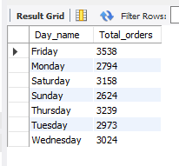

**2. Monthly trend for orders**

SELECT MONTHNAME(STR_TO_DATE(ORDER_DATE, '%d-%m-%Y')) AS Month,

Count(DISTINCT order_id) AS Total_orders From Pizza_sales

GROUP BY Month ORDER BY Total_orders DESC;

*Output:*

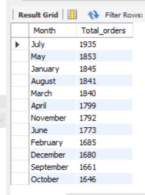

**3. PCT of sales by pizza category**

SELECT Pizza_category,

ROUND(SUM(total_price),2) AS TOTAL_SALES,

ROUND(SUM(total_price) * 100 / (SELECT SUM(total_price) FROM pizza_sales),2) AS PCT

FROM pizza_sales GROUP BY Pizza_category ORDER BY PCT DESC;

*Output:*

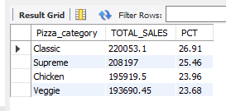

**4. PCT of sales by Pizza size**

SELECT pizza_size,

ROUND(SUM(total_price),2) AS Total_sales,

ROUND(SUM(total_price) * 100 / (SELECT SUM(TOTAL_PRICE) FROM PIZZA_SALES

WHERE QUARTER(str_to_date(ORDER_DATE, '%d-%m-%Y')) = 1),2) AS PCT

FROM PIZZA_SALES

WHERE QUARTER(str_to_date(ORDER_DATE, '%d-%m-%Y')) = 1

GROUP BY PIZZA_SIZE

ORDER BY PCT DESC;

*Output:*

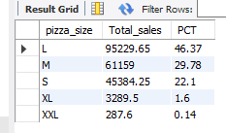

**5. TOP 5 PIZZA BY REVENUE**

SELECT PIZZA_NAME , SUM(TOTAL_PRICE) AS REVENUE FROM PIZZA_SALES

GROUP BY PIZZA_NAME

ORDER BY REVENUE DESC LIMIT 5;

*Output:*

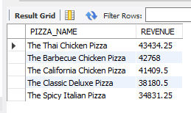

**6. TOP 5 PIZZA BY QUANTITY**

SELECT PIZZA_NAME , SUM(QUANTITY) AS TOTAL_QUANTITY FROM PIZZA_SALES

GROUP BY PIZZA_NAME

ORDER BY TOTAL_QUANTITY DESC

LIMIT 5;

*Output:*

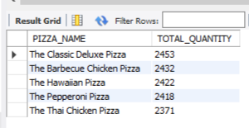

**7. TOP 5 PIZZA BY ORDERS**

SELECT PIZZA_NAME , COUNT(DISTINCT ORDER_ID) AS TOTAL_ORDERS FROM PIZZA_SALES

GROUP BY PIZZA_NAME

ORDER BY TOTAL_ORDERS DESC

LIMIT 5;

*Output:*

